# Linux Lab 2, users and groups--key

# Turn in your answers for the last questions marked with **

## Reading

Read the PowerPoint in Canvas entitled Linux Users and Groups

Read “The Linux Command Line”, pp 87-93 about su and sudo

## Lab

Ubuntu locks the root account for security reasons, but most other distributions don’t. In order to give you practice in the way other distributions use the su command, we will enable the root account by giving it a password. Don’t fall into the habit that Ubuntu is trying to prevent, which is running everything as the root user!

Enter this command to assign a password to the root account:  
sudo passwd root  
Then enter the password twice.  
Obviously, you want to remember the password…

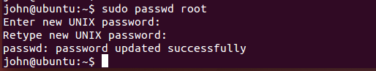

1. Create a new user. I'll refer to it as testuser, but you can call it whatever you want. Note: Remember that your regular user will not have the power to add users, so you will have to use sudo or switch to the root account with su - to get root privileges.

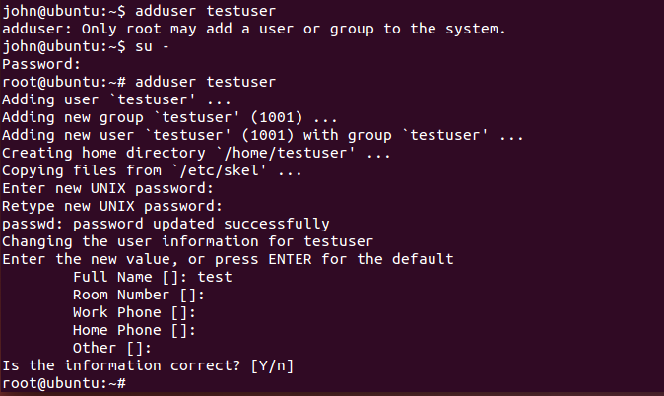

1. Give testuser a password, hopefully something you can remember.
2. Change to user testuser. If you are comfortable switching users at the terminal, you can just use the command  
   su - testuser. If you get confused over which user account you are using, log out and log back in as testuser.

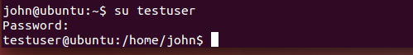

1. Try to use sudo when you are logged in as test user, sudo plus some command. For example, you could use sudo ls (sudo will check your password and membership in the sudoers file, even if the command you use doesn’t require extra rights.) It should not work, because you haven’t given testuser permission to use sudo.

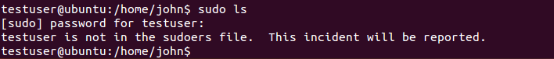

1. By default in Ubuntu, members of the groups named “adm” and “sudo” have access to the sudo command. Use a command from the slides to add testuser to the sudo group. Note: there is also a command usermod, but it has a gotcha--if you aren’t careful you'll give testuser membership in sudo but remove all its other groups (see *, below). (You’ll have to add testuser to the sudo group as root. Use su - to become root, add testuser to the wheel group, and then exit to be back to testuser.)

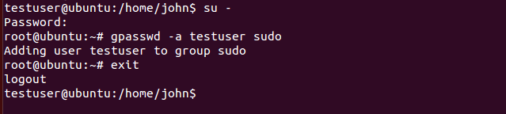

1. Once testuser is in the group sudo try sudo again. You will need to exit the current terminal and open a new one to get Ubuntu to check the sudoers file. Then it should work.

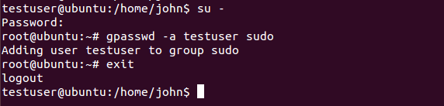

1. Use su - to become root. Examine the file, /etc/sudoers, using less. You should be able to find the line that allows root to use sudo for ALL commands, and other lines that allow members of the adm and sudo groups to do the same. The sudoers file can also give users the permission to run selected commands. Some installations give all users permission to mount CD-ROMs or shutdown the computer by adding lines to /etc/sudoers.

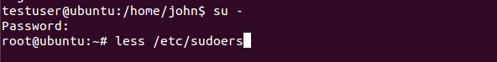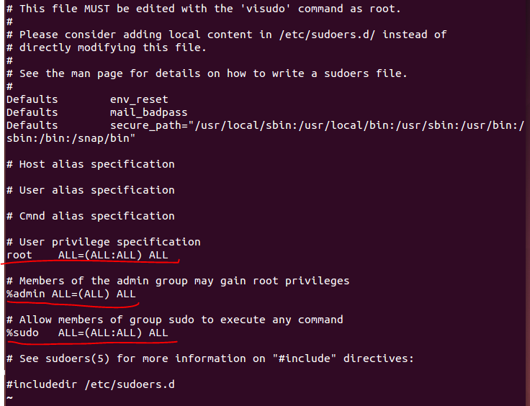

1. Use the less command to examine the /etc/group file. You should see that the user you installed Ubuntu with is a member of adm, sudo, and several other groups.



Some text deleted.

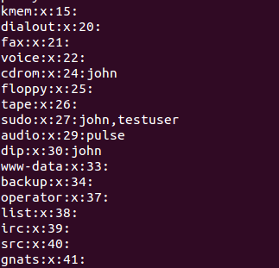

1. Use privileged access (either su - to get to the root account, or sudo from your own account) to remove testuser from the sudo group  
   gpasswd -d testuser sudo (from root) or sudo gpasswd -d testuser (from your account.)

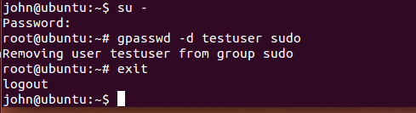

1. Exit from root if you used su -. Test sudo for testuser to make sure it no longer works.

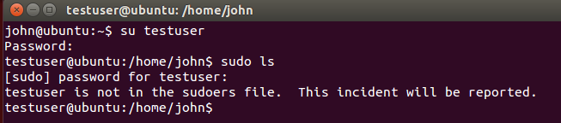

1. **\*\*** How are su and sudo different?

The su command logs you in as the user you specify (or root if none is specified). It asks you for the password of the user you are switching to.

The sudo command executes one command with elevated privileges if your user is listed in the /etc/sudoers file. It asks for your password.

1. **\*\*** Write down the commands you would use to:
   1. create a user called webadmin

sudo adduser webadmin

* 1. set its password to Guru0fHtml

sudo passwd webadmin GuruOfHtml

* 1. give it the same rights to the web server that the group apache has

sudo gpasswd webadmin apache   
or  
sudo usermod -a -G apache webadmin

Now that you are finished, (if you like) lock the root password so your VM is like normal Ubuntu again.  
sudo passwd -l root   (-l is a lower case "L")

The usermod command will replace the list of supplementary groups with the new one unless you tell it to append.

[root@john ~]# usermod --help

Usage: usermod [options] LOGIN

Options:

-c, --comment COMMENT new value of the GECOS field

-d, --home HOME_DIR new home directory for the user account

-e, --expiredate EXPIRE_DATE set account expiration date to EXPIRE_DATE

-f, --inactive INACTIVE set password inactive after expiration

to INACTIVE

-g, --gid GROUP force use GROUP as new primary group

-G, --groups GROUPS new list of supplementary GROUPS

-a, --append append the user to the supplemental GROUPS

mentioned by the -G option without removing

him/her from other groups

-h, --help display this help message and exit

-l, --login NEW_LOGIN new value of the login name

-L, --lock lock the user account

-m, --move-home move contents of the home directory to the

new location (use only with -d)

-o, --non-unique allow using duplicate (non-unique) UID

-p, --password PASSWORD use encrypted password for the new password

-R, --root CHROOT_DIR directory to chroot into

-s, --shell SHELL new login shell for the user account

-u, --uid UID new UID for the user account

-U, --unlock unlock the user account

-Z, --selinux-user SEUSER new SELinux user mapping for the user account

[root@john ~]# usermod -G wheel testuser (Replaces supplementary groups with wheel)

[root@john ~]# usermod -a -G wheel testuser (adds wheel)